Soda Pop Can Hero Engine
TOPIC: Newton's Laws of Motion (Shows the 3 laws)
OBJECTIVE: Rocketry
DESCRIPTION: Water streaming through holes in the bottom of a suspended soda pop can causes the can to rotate.
CONTRIBUTED BY: Tom Clausen, KSC Explorations Station
EDITED BY: Roger Storm, NASA Lewis Research Center
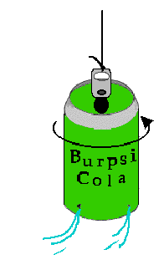

MATERIALS AND TOOLS:
- Empty soda pop can with the opener lever intact
- Nail or ice pick
- Fishing line
- Bucket or tub of water

PROCEDURE:
- Lay the pop can on its side and using the nail or ice pick carefully punch four equally spaced small holes just above and around the bottom rim. Then before removing the punching tool for each hole, push the tool to the right (parallel to the rim) so that the hole is slanted in that direction.
- Bend the can's opener lever straight up and tie a short length of fishing line to it.
- Immerse the can in water until it is filled. Pull the can out by the fishing line. Water streams will start the can spinning.
- If the can does not spin try making the holes larger or adding a fishing swivel to the string above the can.
DISCUSSION: The Soda Pop Can Hero Engine is an excellent demonstration of Newton's Laws of Motion. The can rotates because a force is exerted by the flowing water (1 st. Law). The rate of rotation will vary with different numbers of holes and different diameters of holes in the can (2nd. Law). Try two holes and try a can with large holes verses a can with small holes. The can rotates in the opposite direction from the direction of the water streams (3rd. Law).

