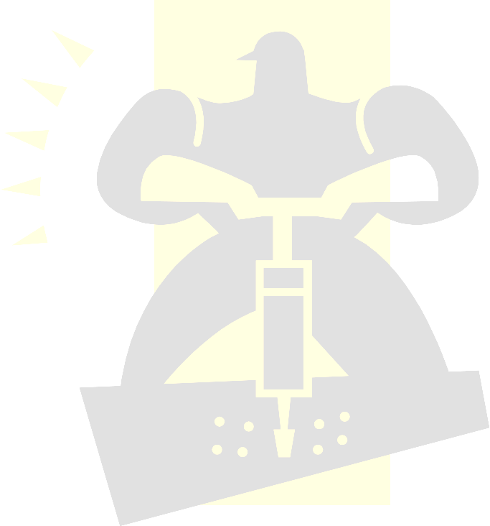
Pneumatics and Hydraulics

Purpose: To introduce the students to the basics of Pneumatic and Hydraulic
Systems, and to apply the basic principles of these systems into a
construction project.

Objectives:
- To learn the terminology and symbols related to Pneumatics and Hydraulics.
- To understand how hydraulic lifts work by achieving mechanical advantage.
- To design a pneumatic system project using a single master cylinder controlling at least two slave cylinders.
- To build a system that works pneumatically to solve a problem.

Portfolio Requirements:
- A complete list of definitions relating to pneumatics and hydraulics.
- A list of the symbols involved in simple hydraulics and pneumatics accompanied by drawings of each of the symbols on the list.
- A drawing of the simple hydraulic system shown on page 188 of the black “Design Technology Book”, and a brief explanation in your own words about how it works.
- Drawings of your own created pneumatic system including at least one master cylinder and two slave cylinders. Examples: elevator, sliding doors, dumb waiter.
- A constructed project based on the designed system in number 6.

Project Outcomes:
Item | Value
Part A Hydraulics and Pneumatics Definitons | 10
Part B Symbols | 10
Part C Drawing of Basic Hydraulic Systems | 15
Part D Draw Scaled diagrams of Pneumatic/Hydraulic Project | 30
Part E Produce a Prototype of Planned Project | 35

Part A: Definitions: (value 10)
All definitions can be found on pages 168-184 “Design and Technology” resources at the back of this book.

- Pneumatics
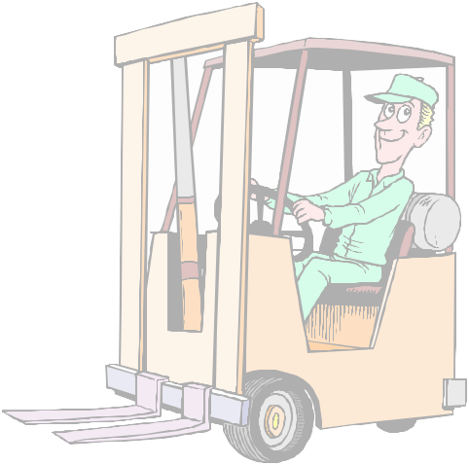
- Hydraulics
- Compressor
- Receiver(tank)
- Spool
- Sensor
- Pressure
- Ports
- Regulator
- Time delay

Part B: Symbols: (value 10)

- Pressure Relief Valve
- Shut off Valve
- Pressure Regulator
- Three Port Valve (air)
- Single Acting Cylinder
- Blocked Port
- Air Flow
- Exhaust
- Air Supply
- Hydraulic Pump (Fixed Displacement)

Part C: Basic Hydraulic Systems (value 15)
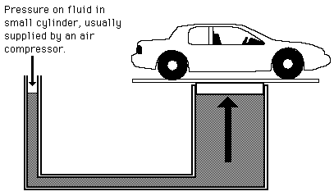
A. Draw the simple hydraulic system on page 188 of your
“Design Technology” book.(Resources at the back of
this book) (value 10)

B. Explain in simple terms the mechanical advantage of a
Hydraulic system like this. What is the trade off in this
system(you are not getting something for nothing…
Why?) (Value 5 )

Part D: Scaled Diagrams of Project (VALUE 30)

- Draw a scaled diagrams (TOP, FRONT, & SIDE VIEWS) of a pneumatic system using a single master cylinder controlling two or more slave cylinders.

- Create a materials list including the amount of wood you need to construct your project.

- Some examples of projects are:
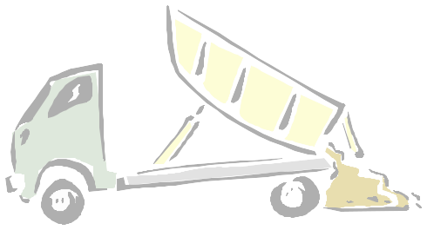
- Jack in the Box
- Elevator
- Sliding door(s)
- Dump truck
- Human Cannon

- EACH student is required to have his/her own drawings.

Part E: Construct your Project (VALUE 35)

- After your diagrams have been approved by your technology teacher you may begin the construction of your prototype.

- Remember to keep strength and operation in mind. This prototype should be a working model.

- You need only build one project between the two group members.

