Newton Car
Objective: To demonstrate Newton's Second Law of Motion by showing the reaction of a rolling car by increasing its mass and acceleration.
TOPIC: Propulsion
Description: In this activity, students test a slingshot-like device that throws a wooden block that causes the car to move in the opposite direction.
EDITED BY: Roger Storm, NASA Lewis Research Center
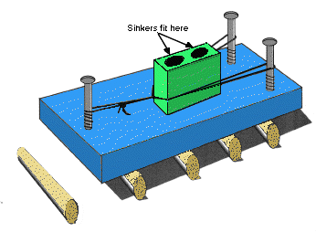

Materials and Tools:
- 1 Wooden block about 1Ox2Ox2.5 cm
- 1 Wooden block about 7.5x5x2.5 cm
- 3 3-inch No. 10 wood screws (round head)
- 12 Round pencils or short lengths of similar dowel rods
- 3 Rubber bands
- Cotton string
- Matches
- 6 Lead fishing sinkers (about 1/2 ounce each)
- Drill and bit (bit size determined by the diameter of the fishing sinkers)
- Vice
- Screwdriver
- Meter stick

Procedure:
- Screw the three screws in the large wood block as shown in the diagram.
- Hold the short piece of wood with a vice and drill two holes large enough to drop two sinkers in each.
- Tie the string into several small loops of the same size.
- Place one string loop over a rubber band and then place the ends of the rubber band over the two screws on one end of the large wood block. Pull the rubber band back like a slingshot and slip the string over the third screw to hold the rubber band stretched.
- On a level table top arrange the pencils or dowel rods in a row like railroad ties. Be sure to mark the position of each dowel rod to make the experiment exactly the same way each time it is tried. Place the large block on one end of the row so that the tips of each single screw points toward the other dowel rods. Slip the small block (without sinkers) into the rubber bands.
- Light a match and ignite the ends of the string hanging down from the loop. When the string burns through, the rubber band will throw the block off the car and the car will roll in the other direction. Measure how far the car travels along the table top.
- Reset the equipment and add a second rubber band. Again, light the string, then measure and record how far the car travels.
- Reset the equipment and try again with 3 rubber bands. Then try again with one rubber band and two sinkers, 4 sinkers, etc.
- Plot the data from each of the experiments on a graph like the one below.
Discussion: The Newton Car provides an excellent demonstration of Isaac Newton's Second Law of Motion. By repeated trials of the experiment, it will become clear that the distance the car travels depends on the number of rubber bands used and the mass of the block being expelled. By adding sinkers to the block, the mass of the block is increased. By adding rubber bands, the acceleration of the block increases. (Refer to the chapter on rocket principles for a more detailed explanation of this law. The cannon and cannon ball example in the chapter is very similar to the Newton Car.)
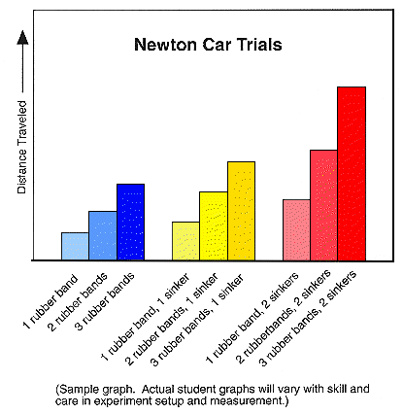

Teaching Notes and Questions:
This activity offers a number of opportunities to combine science and mathematics. Mathematic skills that can be employed include measurement, recording data, plotting data on a graph, and interpreting graphical data.
Because this activity involves the use of matches, be sure to exercise proper safety procedures.
Caution: Provide adequate ventilation and a place to dispose of used matches. Scissors can be substituted for the matches but are not as effective. Using scissors requires some practice because the scissors must be quickly withdrawn after cutting the string so as to not interfere with the reaction motion of the car. Permit students to test this principle for themselves by first stepping and then jumping off a stationary skateboard. Observe how far the skateboard travels.
Caution: Be sure to have a student spotter nearby so the student will not get hurt jumping from the skateboard.

