Here are 9 activities relating to characteristics of air that I have gathered from the internet from Tufts University at the URL http://www.ceeo.tufts.edu/ldaps/htdocs/curriculum/curriculum/list.html

Balloon Scale: Air has weight
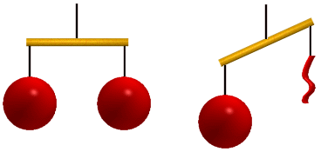
Objective: This demonstration shows that air has weight even though it is invisible.
Materials: Two balloons of the same shape, a wooden rod, string.
Procedure: Blow up both of the balloons so that they are the same size and tie them with string. Tie the string to either end of the rod. Tie another piece of string to the centre of the rod, so that the balloons balance as shown. Let the air out of one of the balloons. The balloon scale will now be tilted.
Explanation: When the balloons are both filled with air, they weigh the same, and therefore balance. When the air is let out of one of the balloons, they no longer have the same weight. The balloon filled with air is heavier than the balloon with no air inside it, and therefore drops. The key is that the full balloon has air at a slightly higher pressure (hence greater density) than the surrounding air.

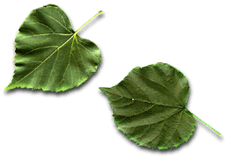
Air Velocity
Objective: Depending on the age of your students, you may want to introduce the concept that air moves, and in fact can have speed.
Procedure: Have the students observe trees moving on a windy day. Make paper fans and have the students create their own wind. Talk about the airflow students feel when the car window is open.
Explanation: Although you can't see air moving, it is moving all the time. Air can travel with a velocity, just like a car can. It constantly moves around and over surfaces.

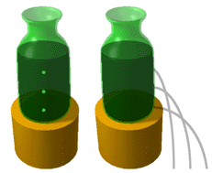
What is Pressure?
Objective: To illustrate the concept of pressure to students using water pressure which they may be able to visualize more easily than air.
Materials: A plastic one-litre soda bottle with three holes, three push pins to plug up the holes, a bottle cap, and a shallow water container.
Procedure: Fill the bottle with water. Observe what happens when you do each of the following.
Uncap the bottle and remove one of the pins.
Cap the bottle.
Squeeze the capped bottle, first lightly, then hard.
Remove all three pins and the cap.
Try removing all combinations of pins with the cap off.
Explanation: With the cap on, no air can get into the bottle and push the water out of the holes. When the cap and pins are removed, the pressure forces water out of the holes. Because there is more water pushing down on the bottom hole than the top hole, the bottom stream is pushed farther than the top stream. That is, with the cap on, the air pressure above the water is below the air pressure outside the bottle. This exactly compensates for the weight of the water, holding it in place. With the cap off, the two air pressures are the same, therefore nothing holds the water back from going out the holes.

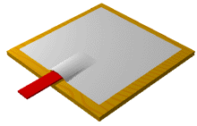
Pressure 2: Air Pressure
Objective: To demonstrate that air exerts pressure.
Materials: A large piece of paper and a ruler.
Procedure: Put the paper down on a table with the ruler underneath it so that about one third of the ruler is hanging off the edge of the table. The student should try to push the ruler (not too hard or the ruler may break) and launch the paper into the air.
Explanation: The student will not be able to lift the paper because there is air pressing down on it. The surface of the paper is large, and therefore there is enough force due to the air pressure on it to prevent it from being moved by the force applied to the ruler.

More Air Pressure
Objective: To further illustrate the concept of air pressure.
Materials: A coffee can or wide mouthed jar, a large plastic bag with no holes, and string or tape.
Procedure: First, put the plastic bag inside the jar so that the mouth of the bag hangs outside of the jar. Tie or tape the bag around the mouth of the jar so that the seal is airtight. Have the students reach into the jar and try to pull the bag out. Next, untie the bag and fill it with air. Attach the bag upside down to the jar as before. Ask the students to try to push down on the bag.
Explanation: When the bag is inside the jar, it is being pushed on by the air outside the jar. To lift it out, the student has to increase the volume of air under the bag, decreasing the pressure. The pressure difference across the bag causes a force pulling the bag back in. The more the student pulls on the bag, the greater this resistance force. When the bag is full of air, however, it acts like a balloon. The pressure on the inside of the bag is greater than the pressure on the outside. As the student pushes down, the volume decreases causing the pressure inside to increase, increasing the resistance force.

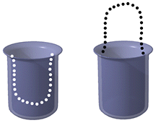

Still More Air Pressure
Objective: To illustrate the concept of air pressure using a phenomenon which students are probably familiar with.
Materials: A drinking straw.
Procedure: Have students suck water into the straw and put their finger over the top of the straw. They can now lift and tilt the straw and no water will escape. When they remove their finger, the water will come out.
Explanation: By holding their finger over the top of the straw, the student is preventing air from coming in, like the soda bottle, the water in the straw drops until the pressure above the water is low enough that the net force due to the pressure difference across the water exactly equals the weight of the water. Air is still pushing on the uncovered bottom, though. When they remove their finger the air comes in through the top of the straw to equalize the pressure and the water falls out.
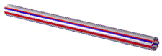

Pressure Versus Velocity

Objective: This demonstration should show that when air flows faster, lower pressure results.
Materials: Each student should be given two straws and a cup half filled with water.
Procedure: The students hold one straw vertically in the water and the other horizontally so that the ends are close together. By blowing air into the horizontal straw, the student causes water to spray out of the vertical straw.
Explanation: By blowing into the straw, the student is increasing the velocity of the air above the straw. This increase in velocity causes a decrease in pressure. The air right above the water in the cup is then at a higher pressure then the air right above the straw. This air pressure pushes the water in the cup downwards, which in turn forces water up and out the straw. The same principle applies when you are drinking out of a cup with a straw. It is the air right above the drink that is pushing the drink out!
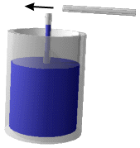

Pressure Versus Velocity II

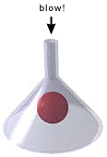
Objective: This lesson is to help explain the concept that where there is faster air flow there is less pressure.
Materials: A clear funnel and a ping pong ball.
Procedure: With the funnel upside down, hold the ping pong ball inside and blow into the small end as you let go of the ball. Students are usually surprised to see that the ball does not fall but stays lodged in the end of the funnel.
Explanation: By blowing into the funnel, the velocity of the air is greater above the ping pong ball than below. When the air reaches the larger cross section, it spreads out and thus slows down. The pressure is less where the air is going faster, above the ball, and greater where the air is going slower, below the ball. A force is created going from high to low pressure, and this keeps the ball up despite gravity.

Pressure Versus Velocity III

Objective: This demonstration shows that greater velocity is found in regions of lower pressure in a flow of air.
Materials: Two books, one sheet of paper, and a straw.
Procedure: The books are placed on a desk side by side with a space in between them. The paper is placed over both books so that it bridges them. The student uses the straw to blow air underneath the paper. This causes a downward force on the paper, and it moves down in the centre.
Explanation: Once again, where there is an increase in the velocity of the air underneath the paper, a lower pressure region is found. A force is created from higher to lower pressure, and this force pushes the paper down.
